Feedback on MiTaL – from Megan, on 4/29/25

Exponentials

6.1:

* In example 6.1.14, the change from (1/2)^t/10.551 to the form 2^-t/10.551 will be difficulty for a number of students to follow (it will appear to them as if this precipitated out of thin air). Could you add “As you may recall from working with negative exponents, …”. Also, do we have a section (maybe an appendix?) on negative exponents? If so, this would be a great place to link to that.
* (General comment on the section) I have found it useful to explicitly point out the initial value. While you have those included, they aren’t explicitly called out.
* Example 6.1.19 – you should be aware that despite one homework problem that uses it, nowhere else do we bring in radicals of index other than 2. That is, the 6th root used in this problem is not something that is covered.
* Kind of missing an example on percentage decrease (form A = A_0(1-p)^t.)
  + You do hit this in example 6.1.23, but it is introduced as a practice with a why it works that way. I found it useful to make a big deal how the percentage increase/decrease is the deviation from the number one. (I even graph `y=3(1)^t and make a deal about how boring it is. Ties back nicely with 1 as the multiplicative identity, and with exponentials changing in a multiplication sort of way…)
* Example 6.1.25 also uses more advanced exponential operations (re-writing 2^(t/2.06) as (2^1/2.06)^t, which I think someone coming out of 055 without 105 would struggle with.
* Right before example 6.1.28 you introduce `e`. This is *probably* the first time our students are seeing it. You may want to say what it is (i.e. explain it is a number like pi that appears in various places, but it is irrational (or maybe even “a decimal that doesn’t repeat and doesn’t end”) and instead of writing the decimal approximation, we use the symbol e.)
  + Side observation: do calculators still have “exp(x)” buttons? I haven’t seen those in a long time, but I don’t make it a habit to look at calculators.
* For problems #1-7, I’d cut those examples down by at least half (no, I do not have nearly that many in my homework. I have only 3.) They are kind of drudge work, and are far simpler than what you are asking them to think through in the section. Keep #7 though because it is the only one with e.
* Btw, #17 (in exercises) is a question I like in this section, but it is a stretch question – they have to guess and test to get the last answer, which is why I have the rounding set to the nearest whole year.
* You spent enough time discussing half life and doubling time, I expected to see more of those problems in the homework.
* There is another question you wrote (I already put it in one of my tests) about finding the percent increase/decrease given `P=P_0e^(2.337t)` -- of course the number in the exponent could change. I think it would be a good idea to have some of those problems here too. (Like Question ID: 1480536).

6.2:

* You may want to precede that first graphing problem with a link to a review of negative exponents (again, an appendix would be useful here). Negative exponents are introduced in 055, but it really is just an introduction.
* Example 6.2.2 – check table values 30*1/4 /neq 15 (lines below also off).
* Example 6.2.7 – can we split the table into two tables next to each other? I’m not sure I understand what is going on with the column of –(-x) either. I see you are drawing attention to the symmetries between y=2^x and y=2^-x, but I don’t think the table adds clarity.
* 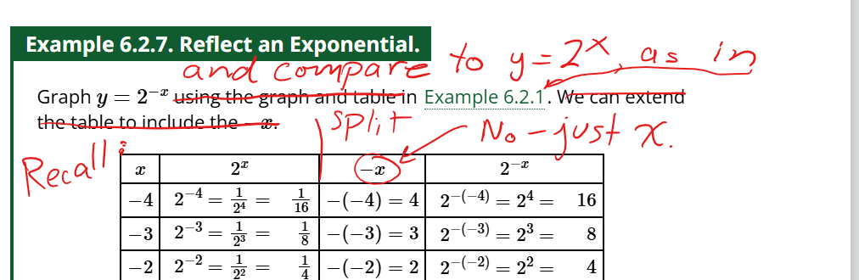
* A general observation: this section is *far* more detailed than anything I do in class. I work on most of the translations in quadratics, and just make a few passing remarks on exponentials. Why all the detail and examples here, with comparatively so little in quadratics? That question can be rhetorical if you wish. It is just odd that for someone so dedicated to applications all the time, you spend so much space in this section on things I have no applications for.
* The homework does not seem in line with the body of the book.

6.3:

* Did not get far enough I this section.

6.4: Did not get to at all.